EXPERIMENT 16

Determination and plotting of Radiation Pattern for a uniform linear array (ULA).
Aim:
To determine and plot the Radiation pattern by Simulating the array factor for a uniform linear array (ULA) using the given parameters and visualize the normalized array factor in polar form.

Software required:
- SCILAB version 6.0.1

Program:

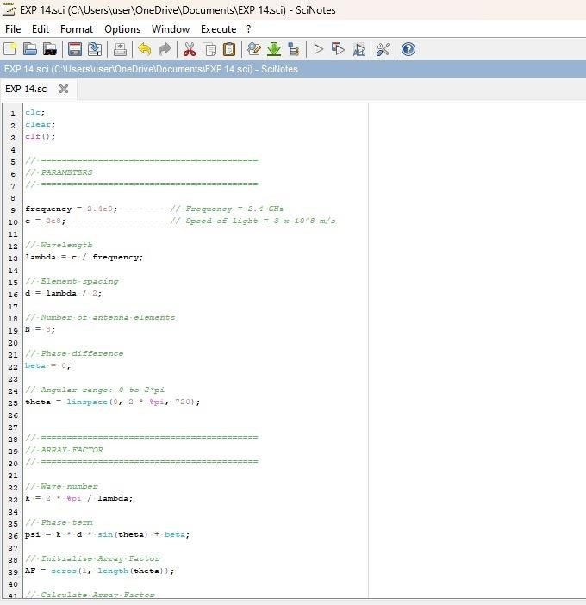

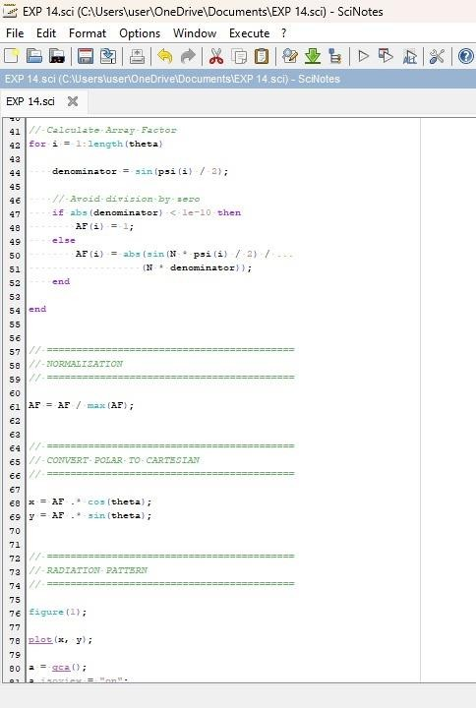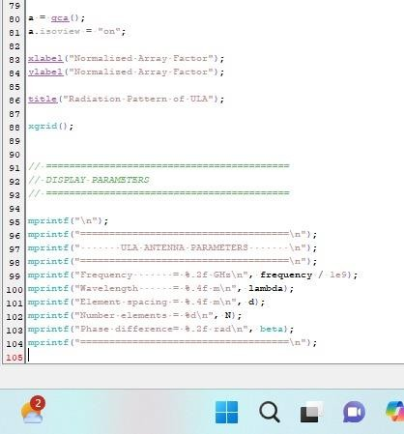

Output:

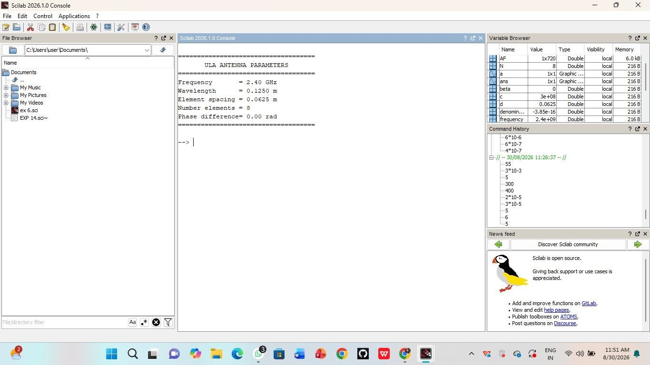
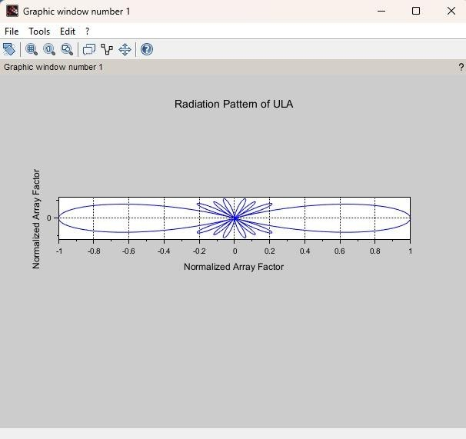

Case Study 1: Optimization of Beamwidth for High-Resolution RADAR Systems
Program:
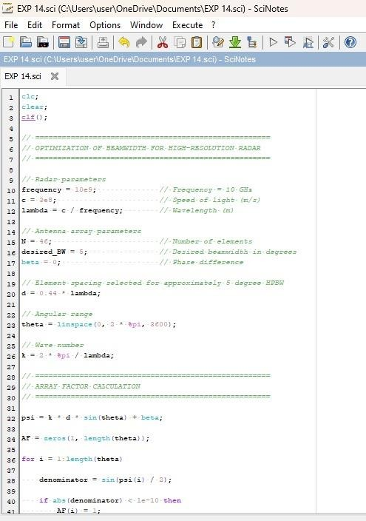
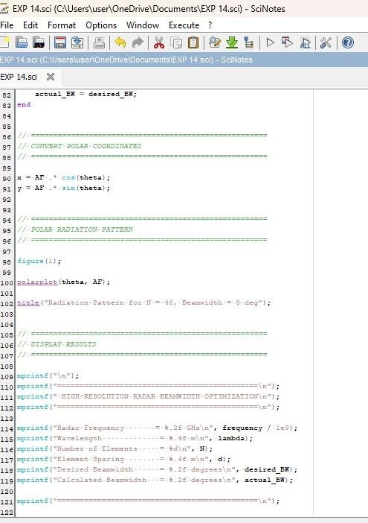

Output:

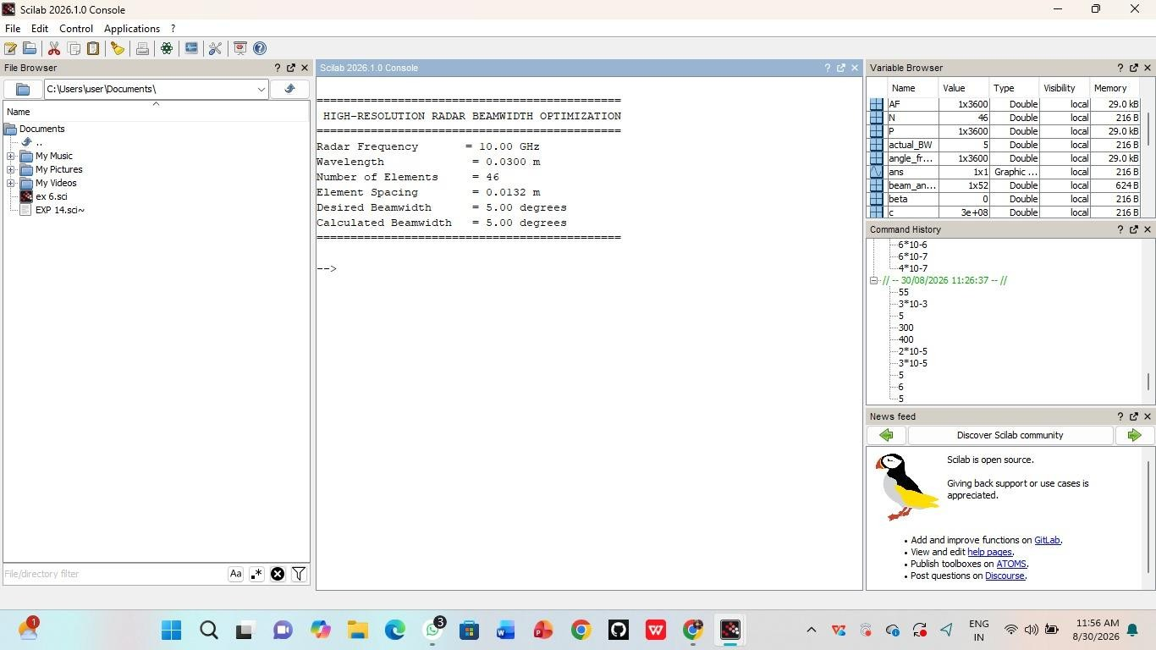
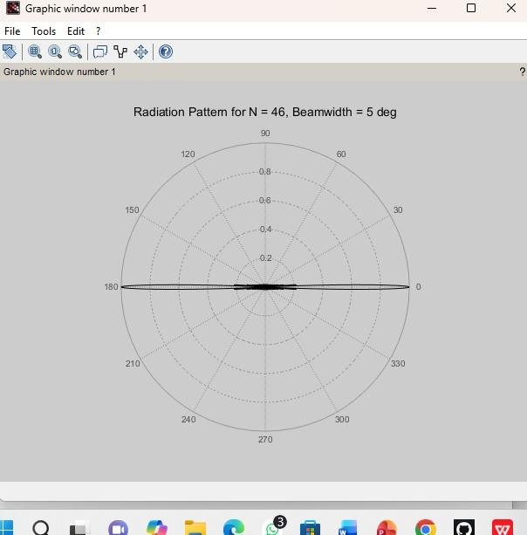

Case Study 2: End-Fire Radiation for Wireless Communications Program:
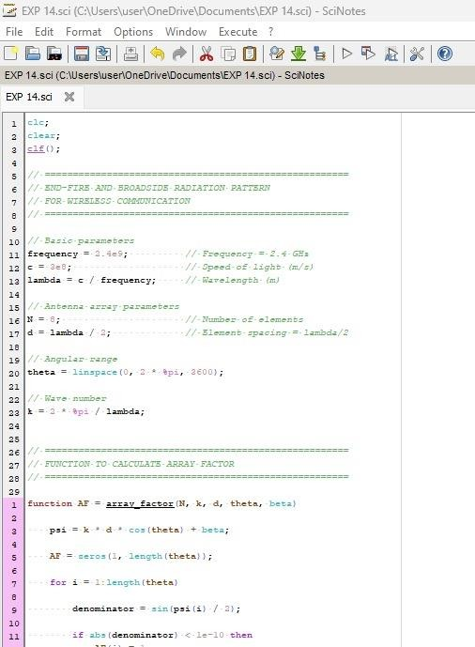
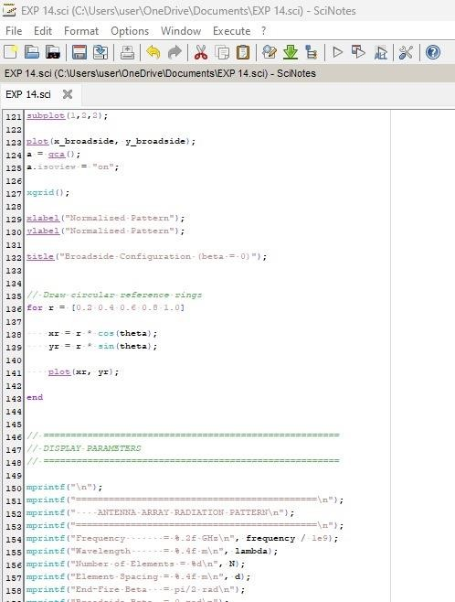

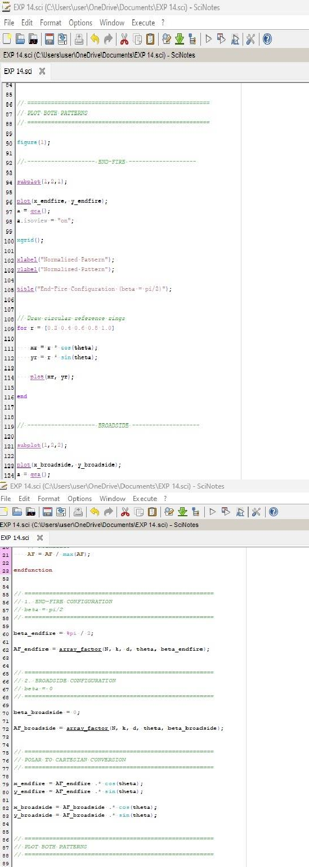

Output:
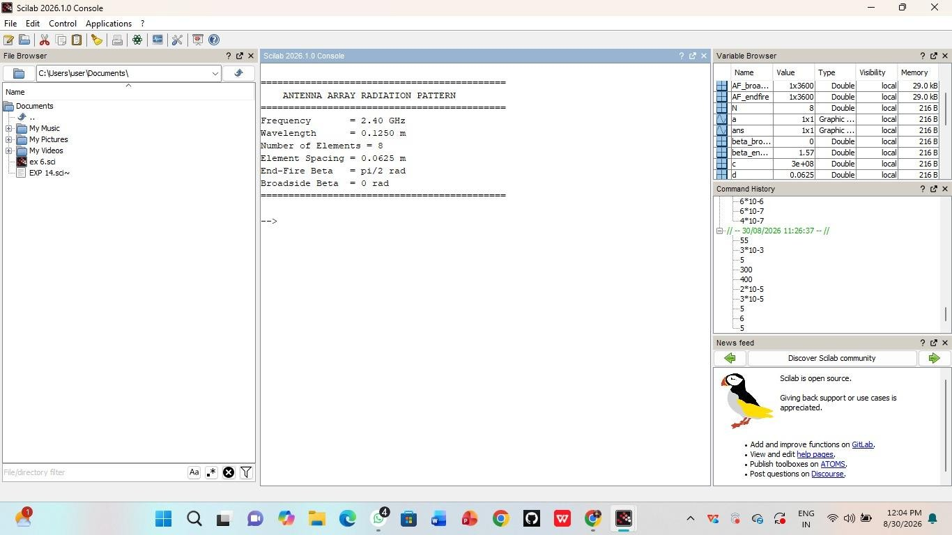

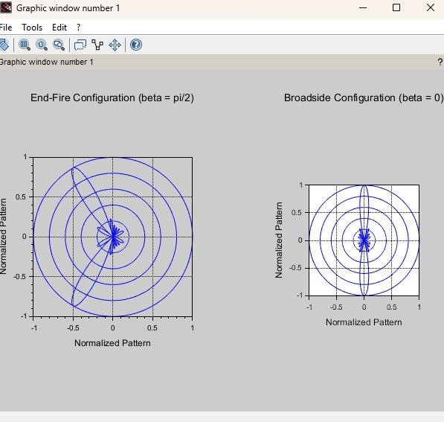

RESULT: The Experiment was done and the radiation characteristics of the ULA is plotted. The different case studies were studied and analysed.

